Obtuse Rhombohedron

Definition
# Source: AI Source: Provided by: [Data Path: Persons Table -> ID Column: 1, Name_En Column: Motasem Essam] -> From: [ChatGPT] on [7/25/2026]
An Obtuse Rhombohedron is a three-dimensional parallelepiped with six congruent rhombus-shaped faces in which all three principal inter-edge angles are obtuse angles (greater than ${90}^{∘}$).
It has six identical rhombus faces, twelve equal edges, and eight vertices. Its overall shape is slanted, with all three principal edge directions forming obtuse angles with one another.
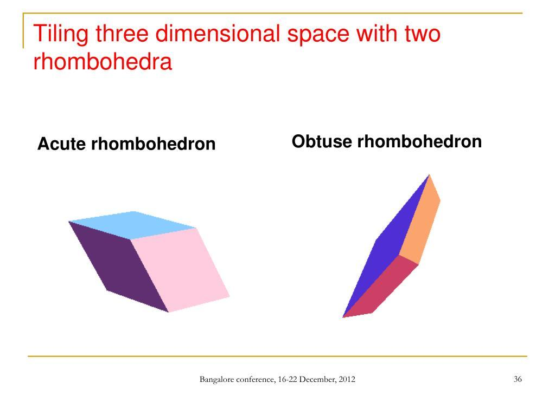

Simple Definition
# Source: AI Source: Provided by: [Data Path: Persons Table -> ID Column: 1, Name_En Column: Motasem Essam] -> From: [ChatGPT] on [7/25/2026]
An obtuse rhombohedron is a solid with six identical diamond-shaped faces, where the three angles between its main edge directions are all greater than ${90}^{∘}$.

Geometric Structure
# Source: AI Source: Provided by: [Data Path: Persons Table -> ID Column: 1, Name_En Column: Motasem Essam] -> From: [ChatGPT] on [7/25/2026]
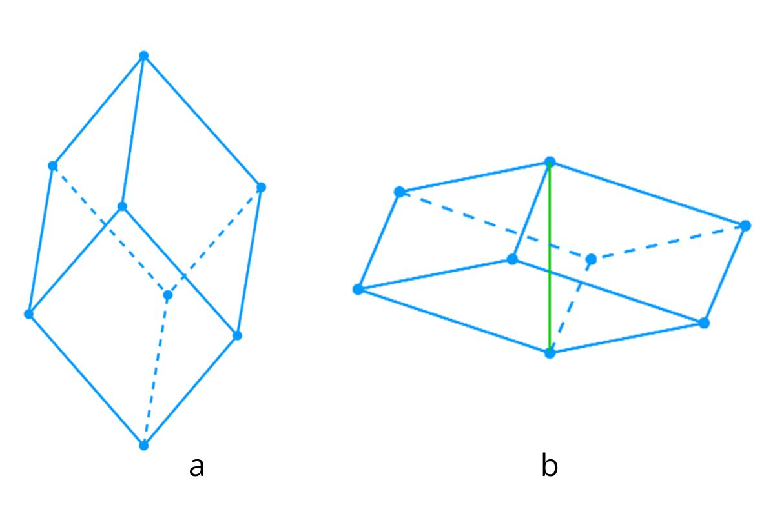
An obtuse rhombohedron consists of the following elements:
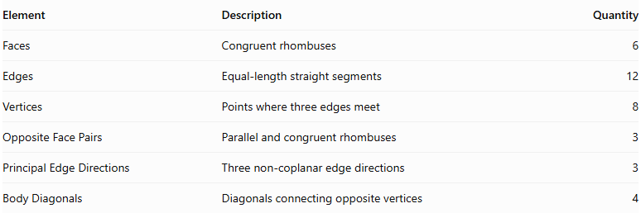
Element | Description | Quantity
Faces | Congruent rhombuses | 6
Edges | Equal-length straight segments | 12
Vertices | Points where three edges meet | 8
Opposite Face Pairs | Parallel and congruent rhombuses | 3
Principal Edge Directions | Three non-coplanar edge directions | 3
Body Diagonals | Diagonals connecting opposite vertices | 4

Main Characteristics

A. Obtuse Inter-Edge Angles
# Source: AI Source: Provided by: [Data Path: Persons Table -> ID Column: 1, Name_En Column: Motasem Essam] -> From: [ChatGPT] on [7/25/2026]
The defining characteristic is that all three principal angles between the edge directions are obtuse.
$$\boxed{{90}^{∘}<α,β,γ<{180}^{∘}}$$
Where:
- $α$ = angle between the first and second edge directions.
- $β$ = angle between the first and third edge directions.
- $γ$ = angle between the second and third edge directions.
These angles describe the spatial arrangement of the three principal edge directions.

B. Faces
# Source: AI Source: Provided by: [Data Path: Persons Table -> ID Column: 1, Name_En Column: Motasem Essam] -> From: [ChatGPT] on [7/25/2026]
All six faces are congruent rhombuses.
Each face has:
- Four equal sides.
- Two pairs of parallel opposite sides.
- Two acute interior angles.
- Two obtuse interior angles.
Important: Although the three principal inter-edge angles are obtuse, each rhombus face still has two acute and two obtuse interior angles.

C. Edges
# Source: AI Source: Provided by: [Data Path: Persons Table -> ID Column: 1, Name_En Column: Motasem Essam] -> From: [ChatGPT] on [7/25/2026]
An obtuse rhombohedron has twelve equal edges.
$$\boxed{E=12}$$

D. Vertices
# Source: AI Source: Provided by: [Data Path: Persons Table -> ID Column: 1, Name_En Column: Motasem Essam] -> From: [ChatGPT] on [7/25/2026]
It has eight vertices, with three edges meeting at each vertex.
$$\boxed{V=8}$$

Mathematical Representation
# Source: AI Source: Provided by: [Data Path: Persons Table -> ID Column: 1, Name_En Column: Motasem Essam] -> From: [ChatGPT] on [7/25/2026]
An obtuse rhombohedron can be described using three equal-length, non-coplanar edge vectors.
Let:
$$|veca|=|vecb|=|vecc|=s$$
Where $s$ is the common edge length.
The angles between the vectors are:
$$α=∠(veca,vecb)$$
$$β=∠(veca,vecc)$$
$$γ=∠(vecb,vecc)$$
For an obtuse rhombohedron:
$$\boxed{{90}^{∘}<α,β,γ<{180}^{∘}}$$
Its eight vertices can be represented by:
$$O, veca, vecb, vecc,$$
$$veca+vecb, veca+vecc, vecb+vecc, veca+vecb+vecc$$
This vector representation describes the complete parallelepiped.

Mathematical Properties

A. Surface Area
# Source: AI Source: Provided by: [Data Path: Persons Table -> ID Column: 1, Name_En Column: Motasem Essam] -> From: [ChatGPT] on [7/25/2026]
All six faces are congruent rhombuses.
If the common edge length is $s$, and the acute interior angle of each rhombus face is $θ$, then:
$$A_{face}=s^{2}sinθ$$
Therefore:
$$\boxed{SA=6s^{2}sinθ}$$

B. Volume
# Source: AI Source: Provided by: [Data Path: Persons Table -> ID Column: 1, Name_En Column: Motasem Essam] -> From: [ChatGPT] on [7/25/2026]
The volume is the absolute value of the scalar triple product of its three edge vectors:
$$V=|veca·(vecb×vecc)|$$
In terms of edge length and inter-edge angles:
$$\boxed{V=s^{3}\sqrt{1+2cosαcosβcosγ-\cos^{2}α-\cos^{2}β-\cos^{2}γ}}$$

C. Euler's Formula
# Source: AI Source: Provided by: [Data Path: Persons Table -> ID Column: 1, Name_En Column: Motasem Essam] -> From: [ChatGPT] on [7/25/2026]
For a convex obtuse rhombohedron:
$$V-E+F=2$$
Substituting:
$$8-12+6=2$$
Thus, it satisfies Euler's polyhedron formula.

Diagonals
# Source: AI Source: Provided by: [Data Path: Persons Table -> ID Column: 1, Name_En Column: Motasem Essam] -> From: [ChatGPT] on [7/25/2026]
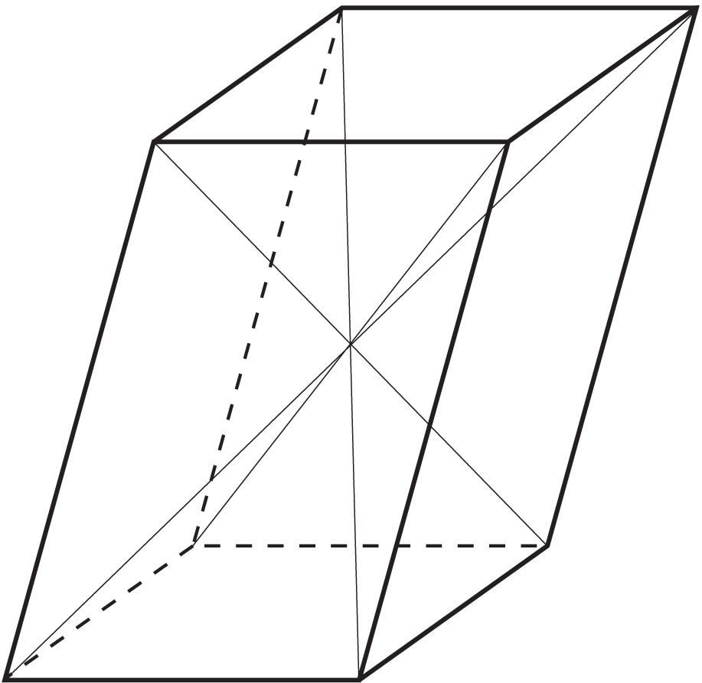
An obtuse rhombohedron has two important diagonal categories.
A. Face Diagonals
Each rhombus face has two diagonals:
- A shorter diagonal.
- A longer diagonal.
B. Body Diagonals
There are four body diagonals connecting pairs of opposite vertices.
Their lengths are not necessarily equal.
For edge vectors $veca,vecb,vecc$, the four body-diagonal vectors, up to direction, are:
$$veca+vecb+vecc$$
$$-veca+vecb+vecc$$
$$veca-vecb+vecc$$
$$veca+vecb-vecc$$

Symmetry Properties
# Source: AI Source: Provided by: [Data Path: Persons Table -> ID Column: 1, Name_En Column: Motasem Essam] -> From: [ChatGPT] on [7/25/2026]
An obtuse rhombohedron has:
- A center of symmetry at the intersection of its body diagonals.
- Three pairs of parallel opposite faces.
- Three pairs of opposite vertices.
- Central inversion symmetry.
A general obtuse rhombohedron does not necessarily have mirror symmetry planes.

Worked Mathematical Examples

Example 1: Finding the Surface Area
# Source: AI Source: Provided by: [Data Path: Persons Table -> ID Column: 1, Name_En Column: Motasem Essam] -> From: [ChatGPT] on [7/25/2026]
An obtuse rhombohedron has an edge length of $6 cm$, and each rhombus face has an acute interior angle of ${60}^{∘}$.
Find its total surface area.
Solution:
Area of one face:
$$A_{face}=s^{2}sinθ$$
Substitute:
$$A_{face}=6^{2}sin{60}^{∘}$$
$$=36×\frac{\sqrt{3}}{2}$$
Total surface area:
$$SA=6×18\sqrt{3}$$
$$\boxed{SA=108\sqrt{3}{ cm}^{2}}$$

Example 2: Finding the Volume
# Source: AI Source: Provided by: [Data Path: Persons Table -> ID Column: 1, Name_En Column: Motasem Essam] -> From: [ChatGPT] on [7/25/2026]
An obtuse rhombohedron has an edge length of $4 cm$, with all three principal inter-edge angles equal to ${120}^{∘}$.
Find its volume.
Solution:
Use:
$$V=s^{3}\sqrt{1+2cosαcosβcosγ-\cos^{2}α-\cos^{2}β-\cos^{2}γ}$$
Substitute:
$$V=4^{3}\sqrt{1+2(-\frac{1}{2})^{3}-3(-\frac{1}{2})^{2}}$$
$$=64\sqrt{1-\frac{1}{4}-\frac{3}{4}}$$
$$=64\sqrt{0}$$
$$\boxed{V=0}$$
This result reveals an important geometric restriction: three equal edge directions with all three mutual angles equal to ${120}^{∘}$ cannot form a nondegenerate three-dimensional rhombohedron.
For a valid obtuse rhombohedron, the three angles must satisfy the positive-volume condition:
$$\boxed{1+2cosαcosβcosγ-\cos^{2}α-\cos^{2}β-\cos^{2}γ>0}$$

Constructing Obtuse Rhombohedron in Solid Geometry

Geometric Instruments Used
# Source: AI Source: Provided by: [Data Path: Persons Table -> ID Column: 1, Name_En Column: Motasem Essam] -> From: [ChatGPT] on [7/25/2026]
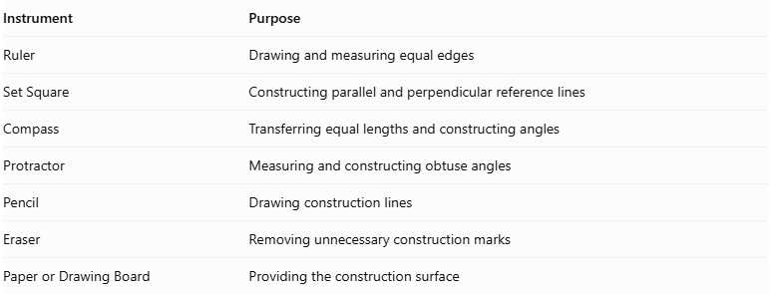
Instrument | Purpose
Ruler | Drawing and measuring equal edges
Set Square | Constructing parallel and perpendicular reference lines
Compass | Transferring equal lengths and constructing angles
Protractor | Measuring and constructing obtuse angles
Pencil | Drawing construction lines
Eraser | Removing unnecessary construction marks
Paper or Drawing Board | Providing the construction surface

Instrument-Based Construction Procedures

Isometric Construction
# Source: AI Source: Provided by: [Data Path: Persons Table -> ID Column: 1, Name_En Column: Motasem Essam] -> From: [ChatGPT] on [7/25/2026]
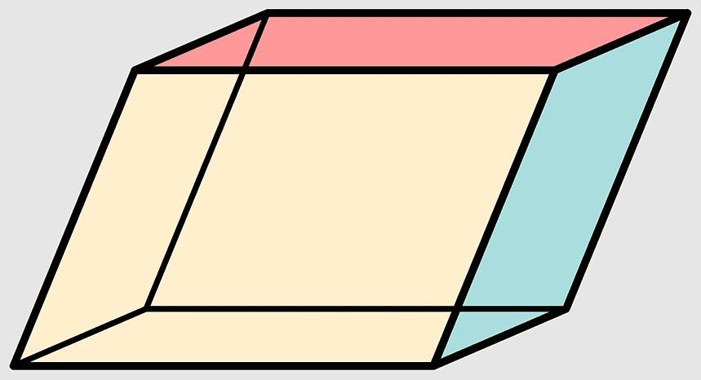
- Select an edge length and three geometrically compatible principal angles, including at least one obtuse angle.
- Draw a rhombus representing the bottom face.
- From its vertices, draw equal, parallel inclined edges in the selected third edge direction.
- Ensure that the resulting principal edge-direction angles include an obtuse angle.
- Connect the upper endpoints to form the opposite rhombus face.
- Complete the remaining faces by connecting corresponding vertices.
- Verify that all twelve edges have equal lengths and all six faces are congruent rhombi.
- Use dashed lines for hidden edges where necessary.

Oblique Projection Construction
# Source: AI Source: Provided by: [Data Path: Persons Table -> ID Column: 1, Name_En Column: Motasem Essam] -> From: [ChatGPT] on [7/25/2026]
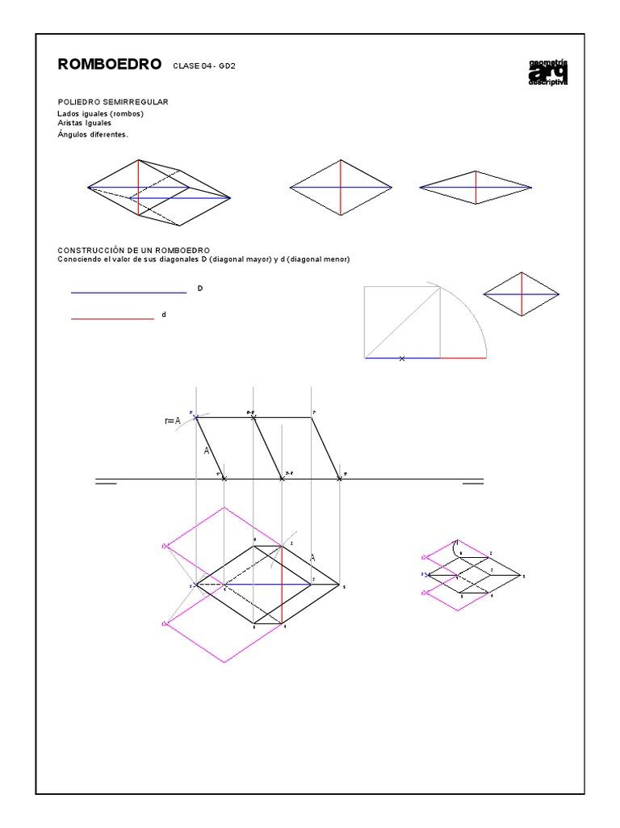
- Draw a rhombus representing the front face.
- Select the direction and inclination of the receding edges.
- Draw equal, parallel receding edges from the four vertices.
- Arrange the edge directions to represent an obtuse rhombohedron.
- Connect the endpoints to construct the opposite rhombus face.
- Complete the remaining edges and faces.
- Check the equality and parallelism of corresponding edges.

Face-Based Construction
# Source: AI Source: Provided by: [Data Path: Persons Table -> ID Column: 1, Name_En Column: Motasem Essam] -> From: [ChatGPT] on [7/25/2026]
- Construct one rhombus face using a ruler and compass.
- Construct five additional congruent rhombi.
- Arrange the faces so that their corresponding edges can be joined.
- Match the six faces along their shared edges.
- Verify that the resulting solid has eight vertices and twelve equal edges.
- Check that at least one principal angle between the edge directions is obtuse.

Edge-Based Construction
# Source: AI Source: Provided by: [Data Path: Persons Table -> ID Column: 1, Name_En Column: Motasem Essam] -> From: [ChatGPT] on [7/25/2026]
- Select and mark the required equal edge length.
- Construct three principal edge directions with at least one obtuse pairwise angle.
- Draw the parallel edges from the appropriate vertices.
- Complete the three sets of opposite parallel edges.
- Connect the vertices to form six rhombus faces.
- Verify the edge lengths, face congruence, and principal angles.

Net-Based Construction
# Source: AI Source: Provided by: [Data Path: Persons Table -> ID Column: 1, Name_En Column: Motasem Essam] -> From: [ChatGPT] on [7/25/2026]
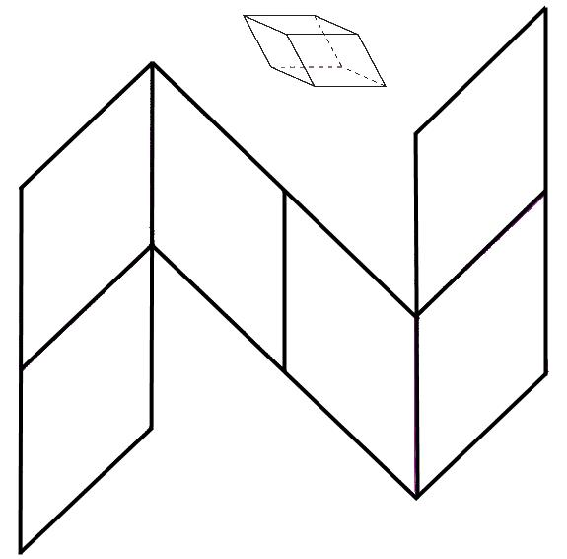
- Draw six congruent rhombi with equal side lengths.
- Arrange the rhombi in a connected net suitable for folding.
- Ensure that adjacent faces share edges of equal length.
- Add tabs if the net is intended for physical assembly.
- Cut and fold the net along the shared edges.
- Join the faces to form the obtuse rhombohedron.

Real-World Applications
# Source: AI Source: Provided by: [Data Path: Persons Table -> ID Column: 1, Name_En Column: Motasem Essam] -> From: [ChatGPT] on [7/25/2026]
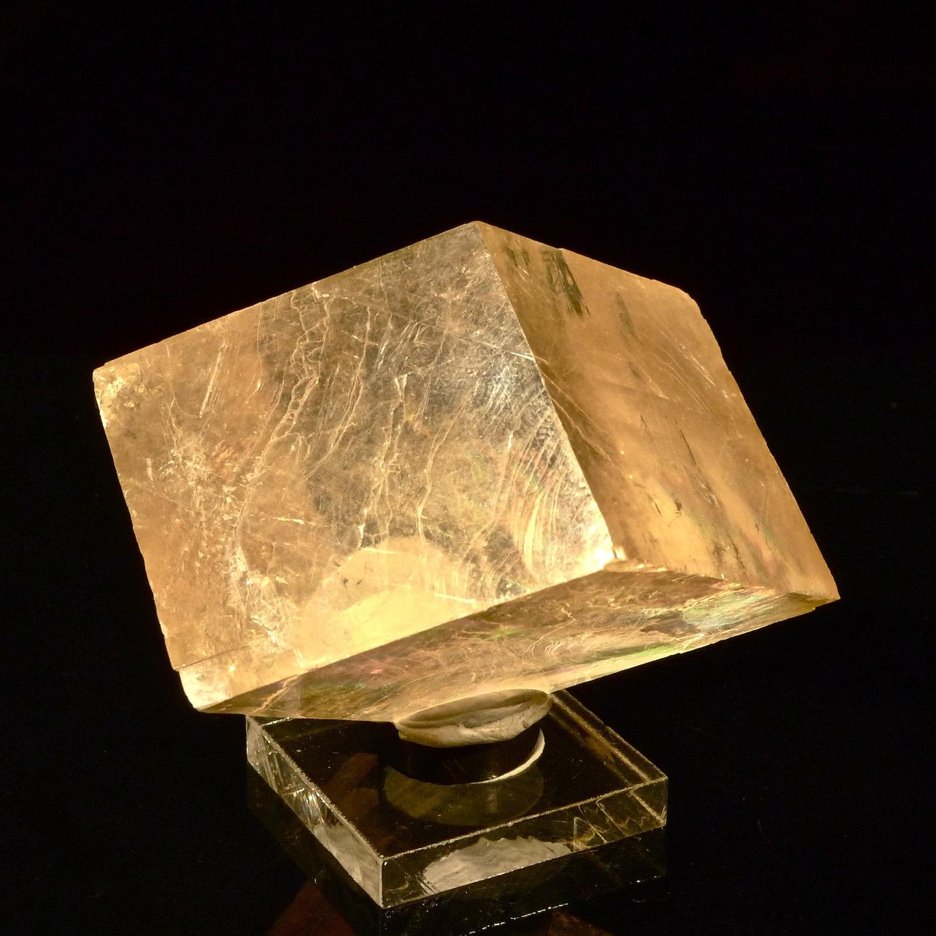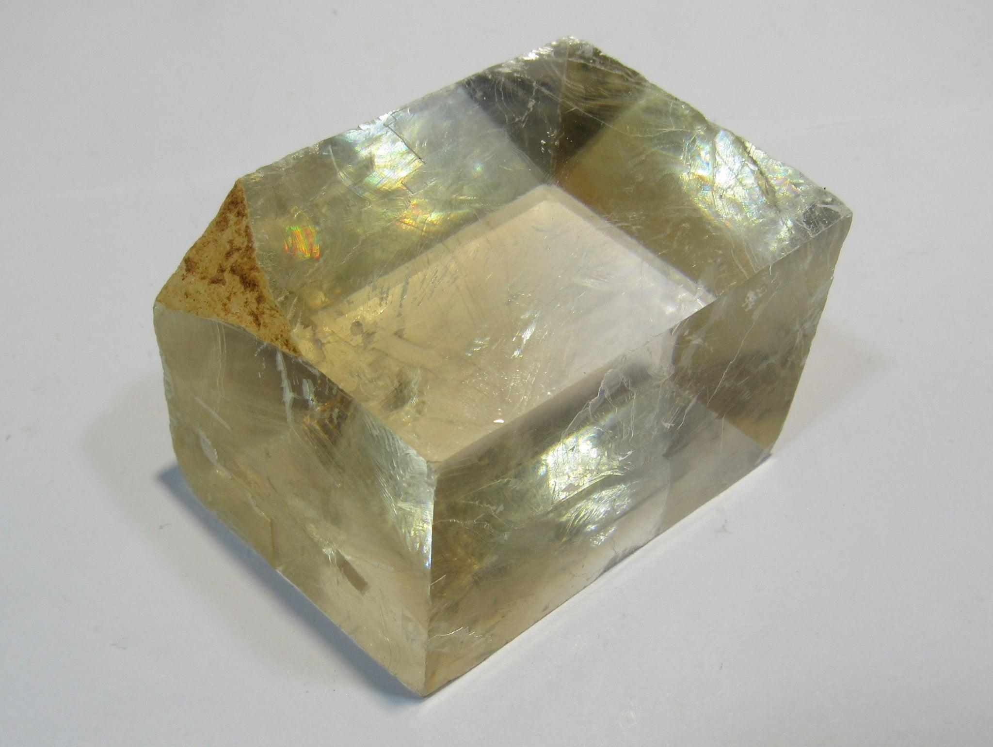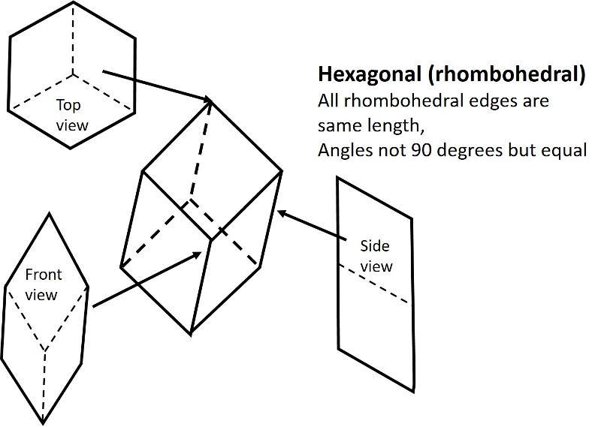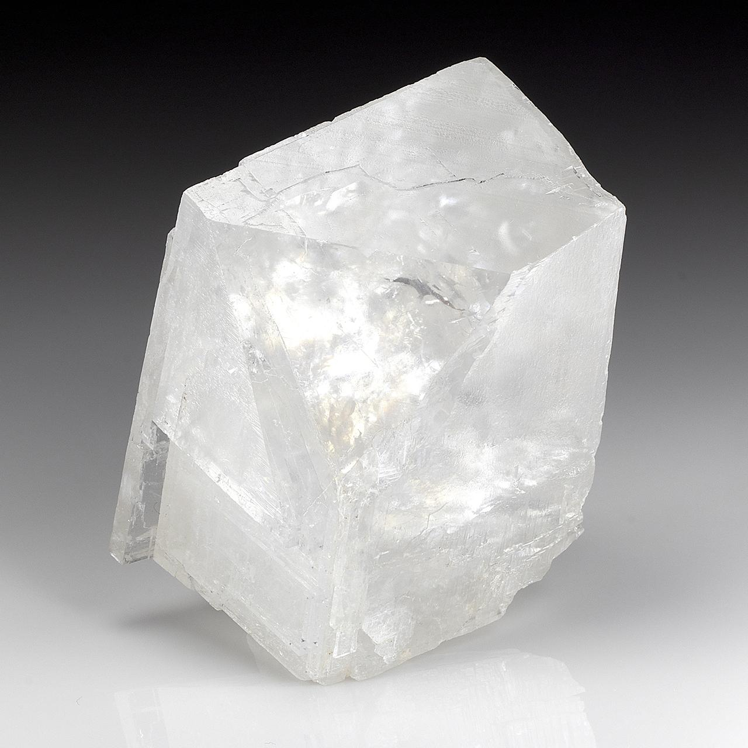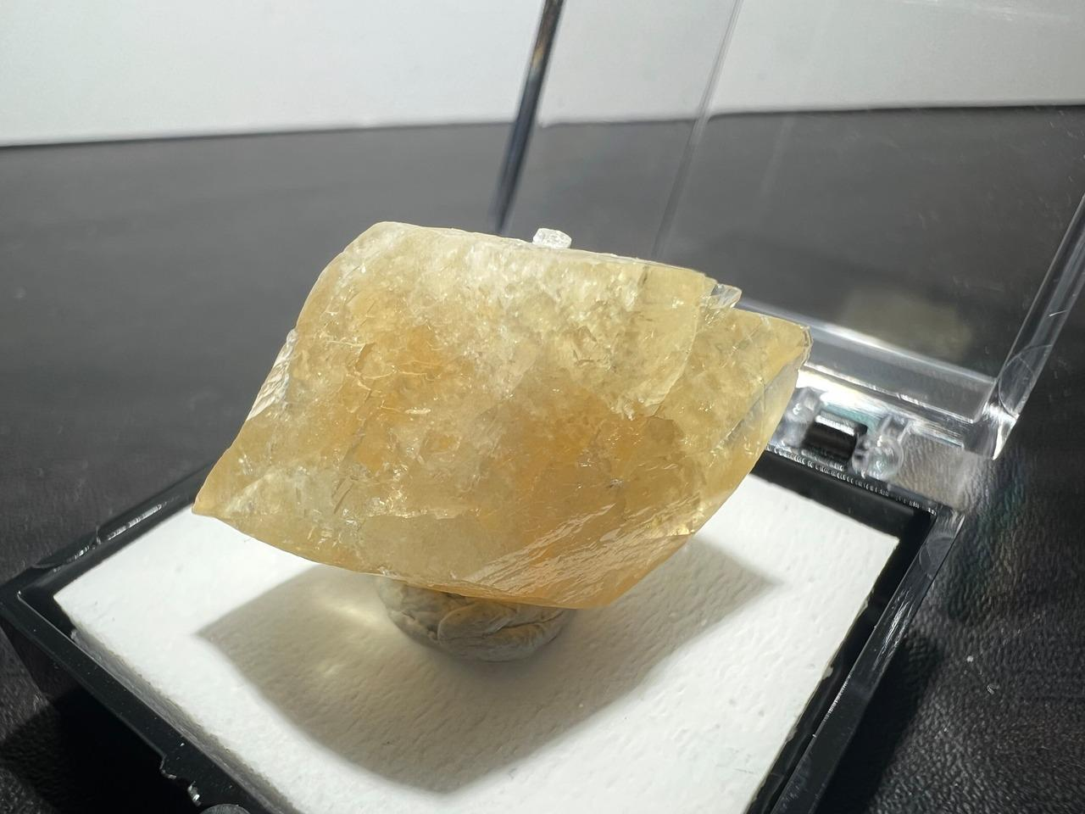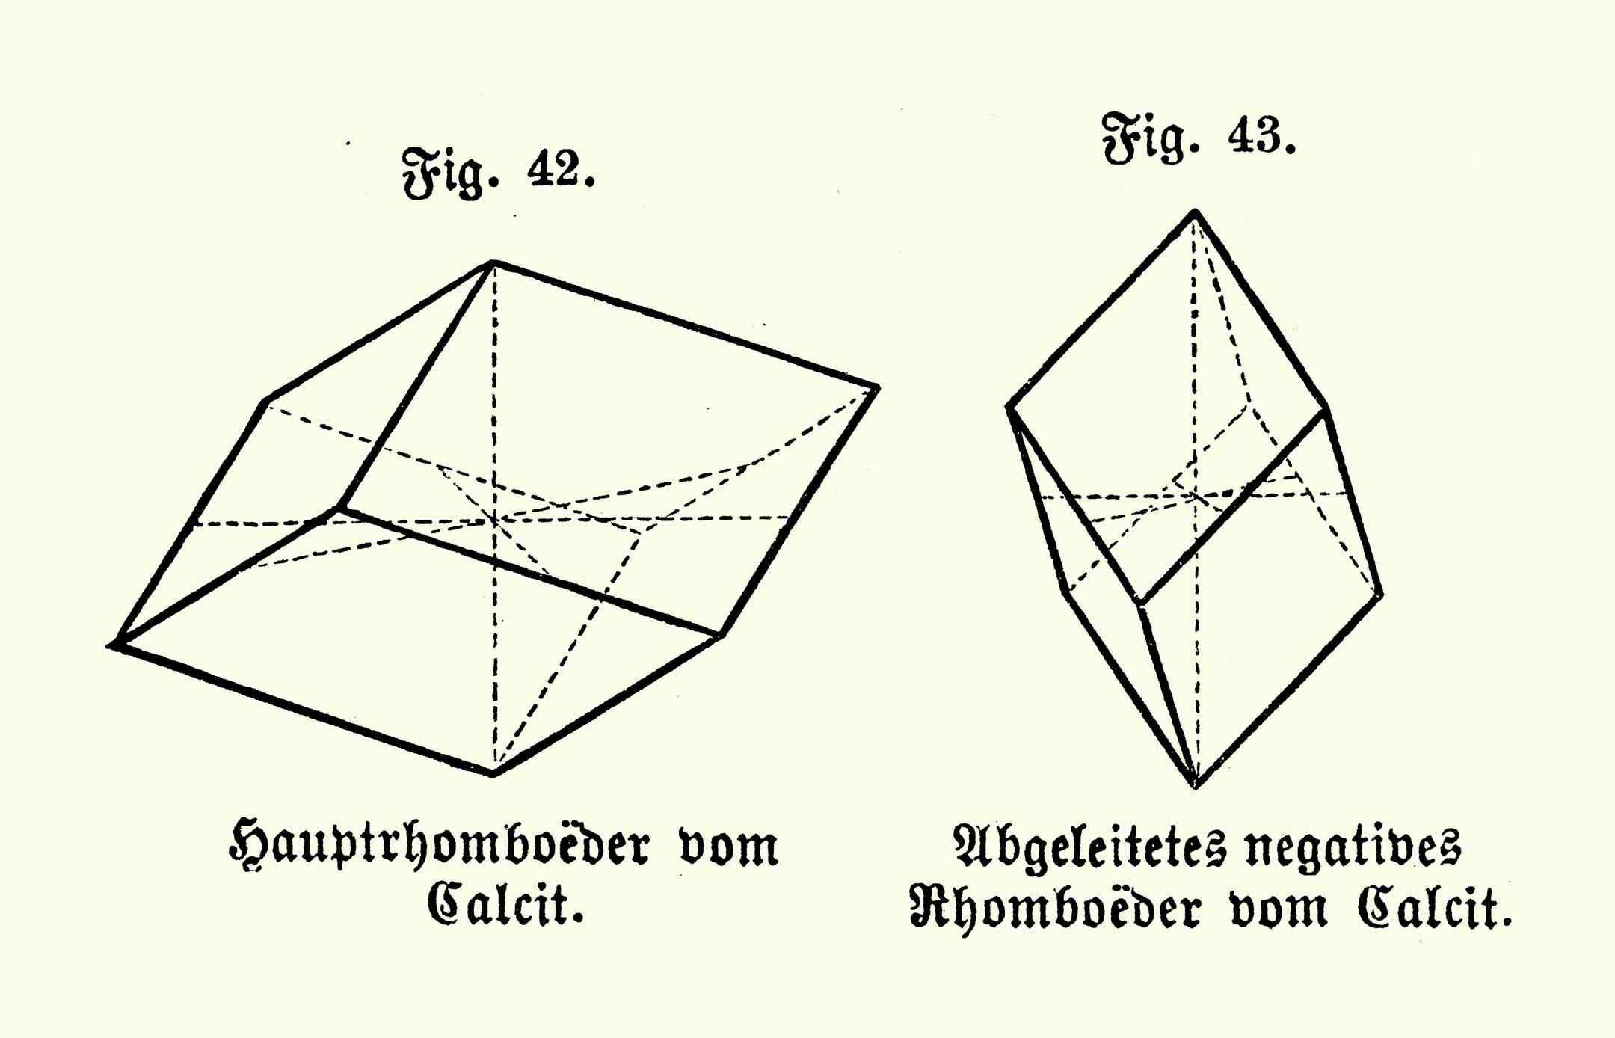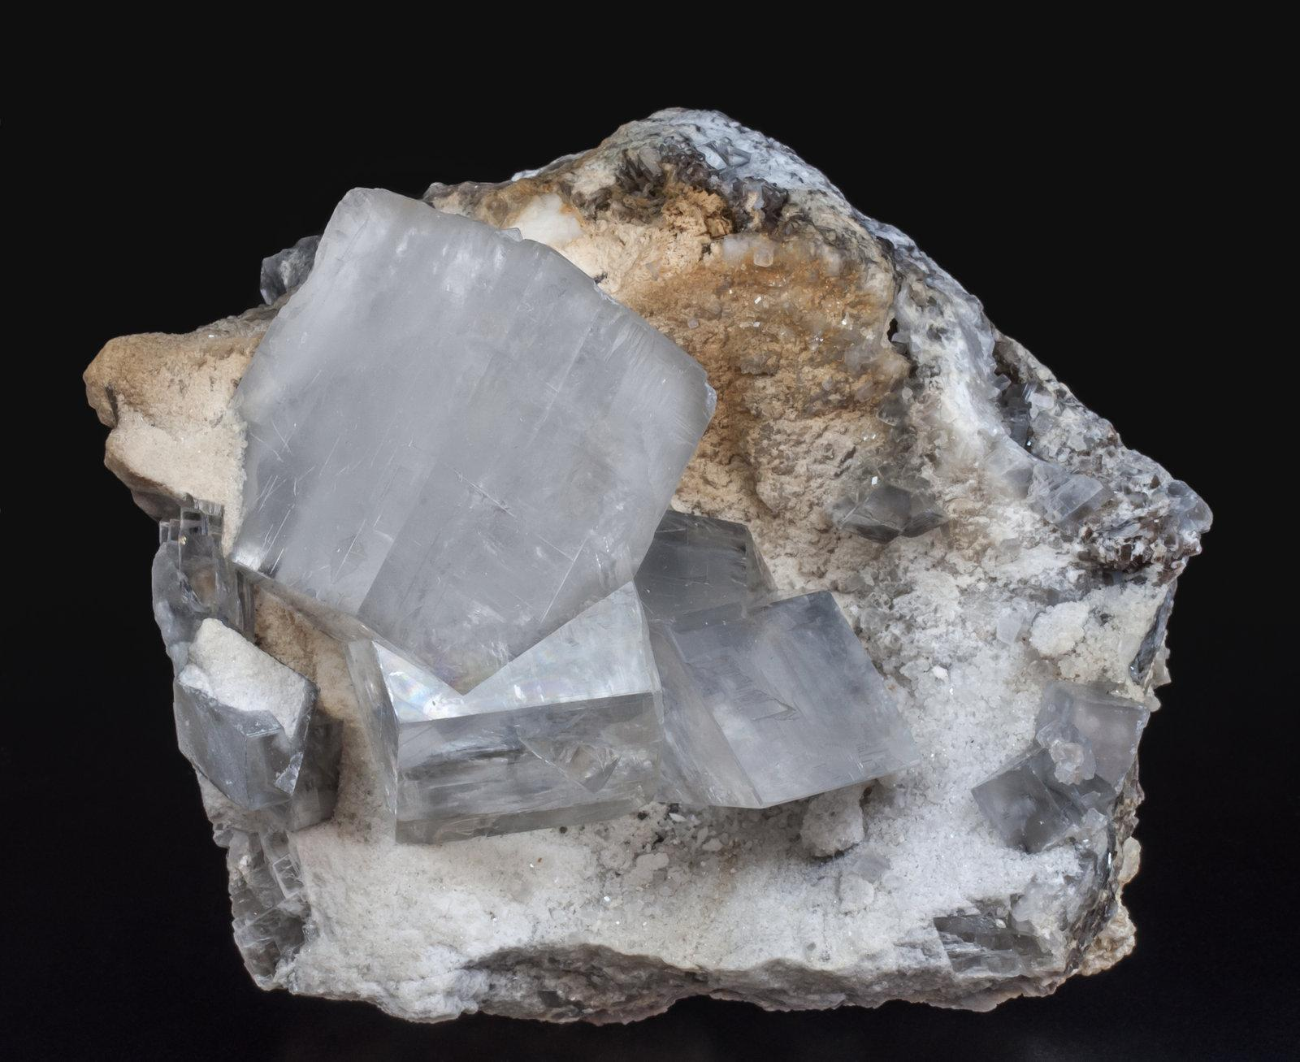
Obtuse rhombohedra are relevant in:
- Crystallography: Describing three-dimensional crystal lattice geometry.
- Mineralogy: Studying rhombohedral crystal forms.
- Geometric Modeling: Representing slanted parallelepipeds.
- Mathematical Geometry: Studying spatial angles, vectors, and solid volumes.

Comparison with Other Rhombohedra
# Source: AI Source: Provided by: [Data Path: Persons Table -> ID Column: 1, Name_En Column: Motasem Essam] -> From: [ChatGPT] on [7/25/2026]
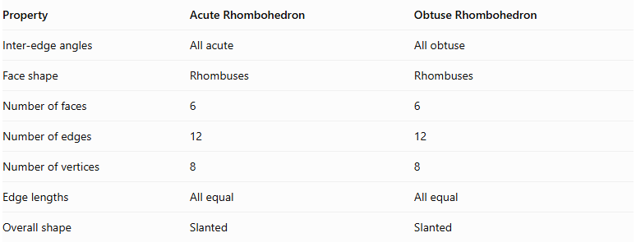
Property | Acute Rhombohedron | Obtuse Rhombohedron
Inter-edge angles | All acute | All obtuse
Face shape | Rhombuses | Rhombuses
Number of faces | 6 | 6
Number of edges | 12 | 12
Number of vertices | 8 | 8
Edge lengths | All equal | All equal
Overall shape | Slanted | Slanted

Key Points
# Source: AI Source: Provided by: [Data Path: Persons Table -> ID Column: 1, Name_En Column: Motasem Essam] -> From: [ChatGPT] on [7/25/2026]
- An obtuse rhombohedron is a special type of parallelepiped.
- It has six congruent rhombus-shaped faces.
- It has twelve equal edges and eight vertices.
- All three principal inter-edge angles are obtuse.
- Its opposite faces are parallel.
- It has four body diagonals.
- Its volume can be calculated using the scalar triple product.
- It has central symmetry but does not necessarily have mirror symmetry planes.
- Its three inter-edge angles must satisfy the positive-volume condition for a valid three-dimensional solid.

Conclusion
# Source: AI Source: Provided by: [Data Path: Persons Table -> ID Column: 1, Name_En Column: Motasem Essam] -> From: [ChatGPT] on [7/25/2026]
The Obtuse Rhombohedron is a three-dimensional geometric solid characterized by six congruent rhombus faces and three obtuse angles between its principal edge directions. It has twelve equal edges, eight vertices, and a center of symmetry. Its spatial geometry and vector-based volume formula make it useful in crystallography, mineralogy, and three-dimensional mathematical modeling.

